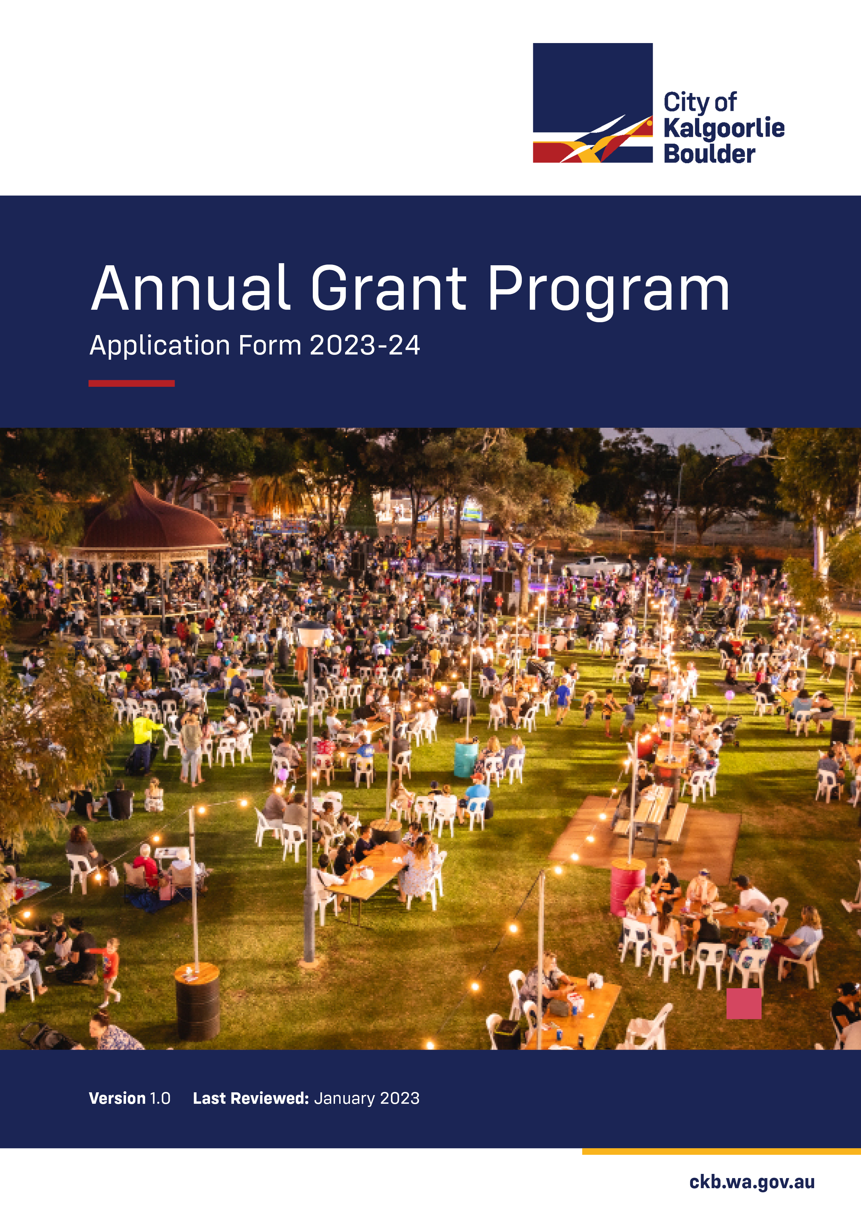

INFORMATION FOR ALL APPLICANTS

The Annual Grant Program 2022-24 opens for applications on Monday 13 February 2023, closing on Friday 28 April 2023, for projects and events which fall within the 2023-24 financial year. Late applications will not be accepted and will be returned.

Please ensure you complete the enclosed application form fully and include all required supporting documentation as outlined in the checklist at the end of this document.

Please note: the City of Kalgoorlie-Boulder will not review and Council will not consider incomplete applications. It is under no obligation to contact applicants to request information that has not been submitted as per the Guidelines.

To assist in processing all applications, we ask you to note the following requirements:

- Before completing your application, please make sure you have read the City’s Annual Grant Program Guidelines;
- For applications that are hand written, please use black ink for photocopying purposes. Only clear and legible hand written applications are able to be processed. If you need space to describe any aspect of your proposed activity please provide the information as briefly as possible on A4 paper, marking clearly the item and page number to which the additional information refers;
- Please supply all supporting documentation with your application and ensure that it is clearly labelled and all information remains in the A4 format;
- Electronic applications (emailed to agp@ckb.wa.gov.au) will be accepted only, please do not provide hard copies.

Applications will be assessed on their individual merit. Applicants may be required to make a presentation to Council on a date to be advised. Outcomes will be announced following the finalisation of the City’s budget adoption process.

City Officers and Council reserve the right not to support applications. Canvassing of Councillors may disqualify applications.

Should you have any questions about the application process, please contact the Annual Grant Program Team by telephone on (08) 9021 9600.

APPLICANT INFORMATION
Organisations applying for funding in the $10,000 and above, and Three (3) Year Service Agreement categories must be incorporated to be eligible for funding. In the under $10,000 category and Capital Works Projects categories, if the applicant is not incorporated (whether an organisation or an individual), an auspice organisation must be nominated to be responsible for the legal contractual arrangements and holding bank account.
Organisation:
ABN (if applicable):
Address:
Postal Address:
Organisation Email:
Contact Person: |  | Position:
Phone: |  | Mobile:
Incorporated: | □ Yes □ No | GST Registered: | □ Yes □ No

AUSPICE ORGANISATION DETAILS
If required, please supply details about your auspice organisation below and obtain a signature from an official representative such as Treasurer, Chairperson, President or Secretary, declaring that the organisation is incorporated and that the information provided in this application is an accurate account of income, expenditures and activities.
Auspice Organisation:
ABN (if applicable):
Address:
Postal Address:
Organisation Email:
Contact Person: |  | Position:
Phone: |  | Mobile:
Incorporated: | □ Yes □ No | GST Registered: | □ Yes □ No

YOUR ORGANISATION
- Tell us about your organisation (200 words or less).
- Briefly describe two (2) of the most significant accomplishments your organisation has achieved for the benefit of the community (200 words or less).

GRANT CATEGORY (Please choose one of the following categories)
For Three (3) Year Service Agreements, please note in the Amount Requested how much you require per financial year. For Capital Works Projects, the City will only fund up to one-third of the total project cost and may require approval from the City’s Building and Planning Department. Please ensure you have read the further information noted in the Guidelines.
□ Annual Grant – under $10,000
□ Annual Grant - $10,000 and above
□ Three (3) Year Service Agreement
□ Capital Works Project
Amount Requested: | $

PROJECT / EVENT DETAILS
Project / Event Name:
Commencement Date: |  | Completion Date:
Venue / Location:
Total Project Costs: | $
Number of people expected to benefit from your project or attend your event:
- Briefly describe your project / event (350 words or less).
- Why are you undertaking this project or hosting this event? Does it address a need or issue in the community?
- How will you spend the requested amount on your project / event?

STRATEGIC COMMUNITY PLAN
Applications must align to the Community Themes, Goals and Objectives contained in the City of Kalgoorlie-Boulder’s Strategic Community Plan 2020-30.

A copy of this plan is available online at www.ckb.wa.gov.au/agp.
Community Theme, Goal and Objective:
Describe how your project / event aligns with this.
Community Theme, Goal and Objective:
Describe how your project / event aligns with this.
Community Theme, Goal and Objective:
Describe how your project / event aligns with this.
The following is an example of how you can do this.
Community Theme, Goal and Objective: |  | Capable
Describe how your project / event aligns with this.
Our project will not only increase the liveability aspect for the local community, but will attract visitors to Kalgoorlie-Boulder because of the unique tourism product we are offering.

Mark the box(es) that best describe the community sector or community group that your project / event will benefit.
□ Arts, culture, events and entertainment  □ Disability services  □ Indigenous and Multicultural affairs  □ Youth and family services  □ Crisis or financial support and counselling  □ Seniors | □ Sport and recreation development services  □ Tourism and promotion  □ Environment and cultural heritage  □ Emergency services  □ Crime prevention and community safety  □ Economic development

PROJECT AND MARKETING PLANNING
- What is the aim, goal or outcome of your project / event?
- Who is your intended audience?
- List five (5) of your project / event tasks (leading up to the project / event) including the time line and risks involved.
 | What are you going to do? | By when? | What could prevent you from doing this?
1.
2.
3.
4.
5.
- How will you market and promote your project / event?

- List the groups and organisations who are supporting your project / event. (Letters of support are required to be attached to this application).
- List three (3) to five (5) methods on how you will evaluate the success of your project / event.
- Detail how you plan to provide recognition of the City of Kalgoorlie-Boulder’s support.

PREVIOUS ASSISTANCE
Has your organisation previously received a grant or financial assistance from the City of Kalgoorlie-Boulder in the last five (5) years?

 □ Yes □ No

Financial Year | Grant / Financial Assistance Type | Amount
 |  | $
 |  | $
 |  | $
 |  | $

PROJECT / EVENT BUDGET
Please read the following information prior to completing your project / event budget:
- Total income needs to be equal to the total expenditure;
- Do not include GST in the budget costings (where appropriate, GST will be added to the successful grant);
- In-kind contribution refers to donations, inclusion of goods or services that have a value (e.g. venue costs, donated materials etc), or volunteer time;
- The value of volunteer time can be calculated at $25 per hour per volunteer;
- Applicants that demonstrate their own financial contributions will be considered favourably;
- Quotes must be supplied for items and services over $5,000;
- Total income and expenditure is for the project / event only.

EXAMPLE BUDGET
Income | Amount | Expenditure | Amount
CKB requested grant | $1,900 | Marketing and Promotion | $650
Cash contribution | $1,500 | Venue Hire | $850
Donations | $500 | Catering | $550
Other grant / funding | $750 | Event fees | $600
Other grant / funding | $500 | Traffic Management | $1,500
Sponsorship | $500 | Entertainment | $1,500
Subtotal Income | $5,650 | Subtotal Expenditure | $5,650
In-Kind Income | Amount | In-Kind Expenditure | Amount
(Community Group Name) volunteer hours x 4 people x 12 hours | $1,200 | (Community Group Name) volunteer hours x 4 people x 12 hours | $1,200
(Printing Company Name) Printing Promotional Materials | $75 | (Printing Company Name) Printing Promotional Materials | $75
Subtotal In-Kind Income | $1,275 | Subtotal In-Kind Expenditure | $1,275
TOTAL INCOME | $6,925 | TOTAL EXPENDITURE | $6,925

You may create a budget template specific to your organisation. Please ensure it does not exceed two (2) A4 pages, includes all relevant information and is clearly identifiable.

ACTUAL BUDGET
Income | Amount | Expenditure | Amount
Subtotal Income | $ | Subtotal Expenditure | $
In-Kind Income | Amount | In-Kind Expenditure | Amount
Subtotal In-Kind Income | $ | Subtotal In-Kind Expenditure | $
TOTAL INCOME | $ | TOTAL EXPENDITURE | $

SUPPORTING DOCUMENTATION CHECKLIST
Please ensure you have enclosed the following supporting documentation with your application. Please note that if you are including an auspice organisation in this application, your sponsor body must provide the required documents on your behalf. Please also note that Three (3) Year Service Agreements may be required to submit a Business Plan to support the organisation’s request for consecutive year funding. Either reconciled or audited financial statements need to be provided with your application, please ensure you read the Guidelines for the requirements.
□ | Evidence of ABN and GST registration (if applicable)
□ | Valid copy of Certificate of Incorporation
□ | Valid copy of Certificate of Public Liability Insurance
□ | Letters of support
□ | Quotes for items and services purchased over $5,000
□ | Most recent copy of reconciled or audited financial statements

DECLARATION
I hereby certify that to the best of my knowledge the information provided is correct, and an accurate account of income, expenditure and project / event activities is disclosed in this application. I also accept and agree to complete an Evaluation and Acquittal Report on receipt of funding support from the City of Kalgoorlie-Boulder.
Name:
Position:
Date:
Signed:

Applications must be received by the City of Kalgoorlie-Boulder by
5:00pm on Friday 28 April 2023.

Incomplete and / or late applications will not be assessed. Applicants can only submit
one (1) grant application per financial year.

Please return your completed application with all required supporting documentation to agp@ckb.wa.gov.au.

Any further information can be discussed with the Annual Grant Program Team on (08) 9021 9600.

